**NERIST ONLINE ACTIVITY FORUM**

A project report submitted on fulfillment of the requirement of

**Web Technology Project**

**Computer Science and Engineering**

By

**Anirban Sarkar (D/15/CS/105)**

**Rachna Raj (D/15/CS/106)**

**Abhishek Kumar (D/15/CS/110)**

Under the guidance of

**Mr. Yogendra Mohan**

Assistant Professor

(Department of CSE)



**NORTH EASTERN REGIONAL INSTITUTE OF SCIENCE ANDTECHNOLOGY.**

**(**Deemed University under section 3 of UGC Act,1956)

**Nirjuli ,Arunachal Pradesh – 791109**

**May-2017**

**DECLARATION**

This is to certify that project entitled “NERIST online activity forum”which is submitted by us in partial fulfillment of the requirement for the award of Diploma in Computer Science & Engineering in NERIST, Nirjuli, Arunachal Pradesh comprises only our own work and due acknowledgement has been made in the text to all other material used.

Anirban Sarkar

D/15/CS/105

Rachna Raj

Date: 11th May, 2017 D/15/CS/106

Abhishek Kumar

D/15/CS/110

**CERTIFICATE**

This is to certify that the project titled “**NERIST ONLINE ACTIVITY FORUM”**submitted by **Anirban Sarkar(D/15/CS/105)** , **Rachna Raj (D/15/CS/106)** , and **Abhishek Kumar(D/15/CS/106)**  in the fulfillment of the Web Technology Project in Computer Science and Engineering Department in **NORTH EASTERN REGIONAL INSTITUTE OF SCIENCE AND TECHNOLOGY(NERIST)** is a record of bonafied work carried out by them under our guidance and supervision.

The result embodies in this project report have not been submitted to any other University for award or Institute for the award of any Degree or Diploma.

**Date: 11th May, 2017** **Project Supervisor**

Mr. Yogendra Mohan

Assistant Professor

Department of CSE

**TABLE OF CONTENTS**

**S.NO. PARTICULARS PAGE NO**

1. ACKNOWLEDGEMENT I

2. INTRODUCTION 1

3. OBJECCTIVES 2

4. FEASIBILITY STUDY 3

5. PROPOSED METHODOLOGY 4

6. EXPERIMENTS AND RESULTS 6

7. VIEW TO OUR WORK 12

8. FUTURE ENHANCEMENTS 20

9. CONCLUSIONS 21

10. REFERENCES.  22

**ACKNOWLEDGEMENT**

No task can be achieved alone, particularly while attempting to finish a project of this magnitude. It took many very special people to facilitate it and support it . Hence we would like to acknowledge all of their valuable supporters and convey our humble gratitude to them.

We would like to thank our project guide **Mr. Yogendra Mohan** who has always been open to discussion and frequently enquired about the project and any problem faced. He has also given us valuable guidance as how to go about the project.

We have put our best effort to make this project usable , informative , and understandable as possible. We have done the best we could do and have been honest to the professor and most importantly to ourselves.

Thank you all for supporting us in making this project a reality.

I

**INTRODUCTION**

The methods with which we as humans interact with computers doing this number crunching around the world are referred to as **web technology**. In the past few decades, it has accelerated greatly, from a few marked up web pages to the ability to do very specific work on a network without interruption. In this lesson, we'll dig further into web technologies before seeing where the trends are taking us.

There are basically two main types of website - **static and dynamic**.  
A **static site** is one that is usually written in plain HTML and what is in the code of the page is what is displayed to the user.

A **dynamic site** is one that is written using a server-side scripting language such as PHP, ASP, JSP, or ColdFusion. In such a site the content is called in by the scripting language from other files or from a database depending on actions taken by the user.

We, for making this site have used HTML, CSS, JAVASCRIPT, PHP MySQL.

Our site is mostly dynamic in nature, but it also do have some static pages, which are basically for sharing information.

The basic purpose, behind designing this site is to eliminate the hectic situations that we face every semester during registration process.

And it also has some quizzes specially prepared branch-wise, by respective subject teachers.

1

**OBJECTIVES**

The purpose of the project work is to create an interactive GUI based application using HTML,CSS,JavaScript PHP, MySQL. To design an online activity forum where students can perform all kind of registration process (like semester registration, late registration, back paper registration) online. Here student can test their knowledge by attending to quizzes, prepared by the respective subject teachers. The teachers have an option to set the question papers online for the quiz. Student can have a direct contact to their department faculties very easily. They can get help and support easily. So, it will help to enhance the teacher-student relationship.

2

**FEASIBILITY STUDIES**

The project we made is feasible in all regard. As it was planned after proper planning of all aspects of a project feasibility. By this project one can perform his/her complete registration online which will reduce the rush on the registration day , it will also help students ,faculty members and staffs to go with the registration process in an easy way .

This project is also feasible from educational background as it contains the quiz section in all respective departments. This will also enhance the connectivity among students and teachers.

3

**PROPOSED METHODOLOGY**

We are working in crystal method, as per which the project processes are given a medium priority. Instead of the processes, this method focuses more on team communication, team member skills, people and interaction with guides and teachers.

4

**EXPERIMENTS AND RESULTS**

This project is a result of many experiments, that we have done throughout this semester. Not only for backend but, also for its frontend, we had spent a huge amount of time to make it look cool, attractive and user-friendly.

First, we started with the main page of our site, for which we had spent a fair amount of time, for giving it a good and cool look. Our tries are as follows:

1. First look for our website(what we had thought).

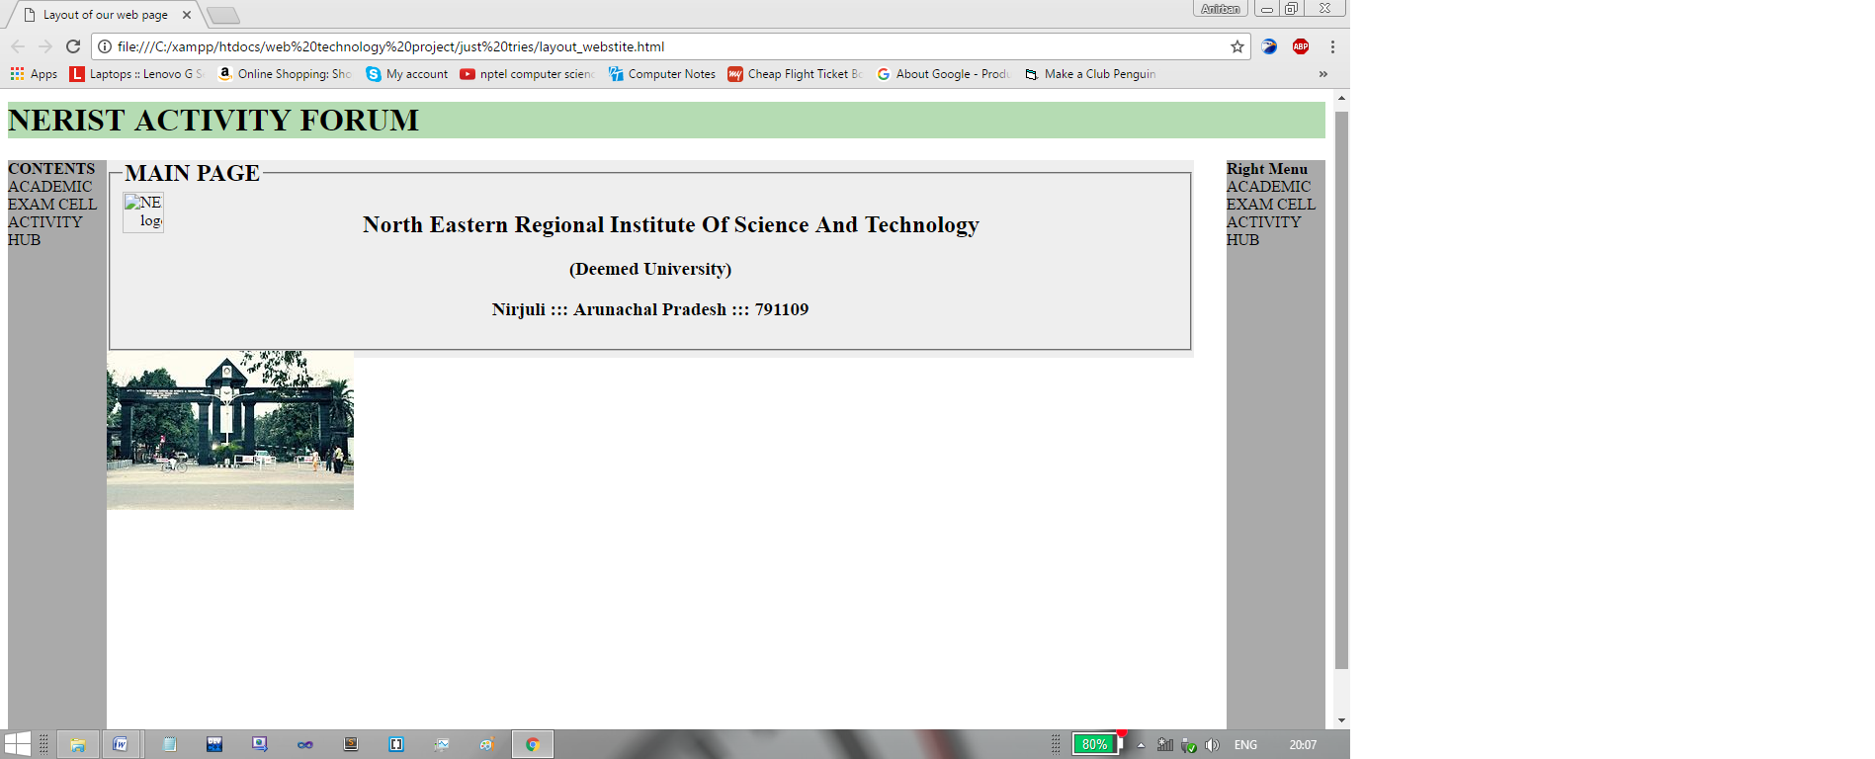

5

**2.** Then we thought for making this our main page.

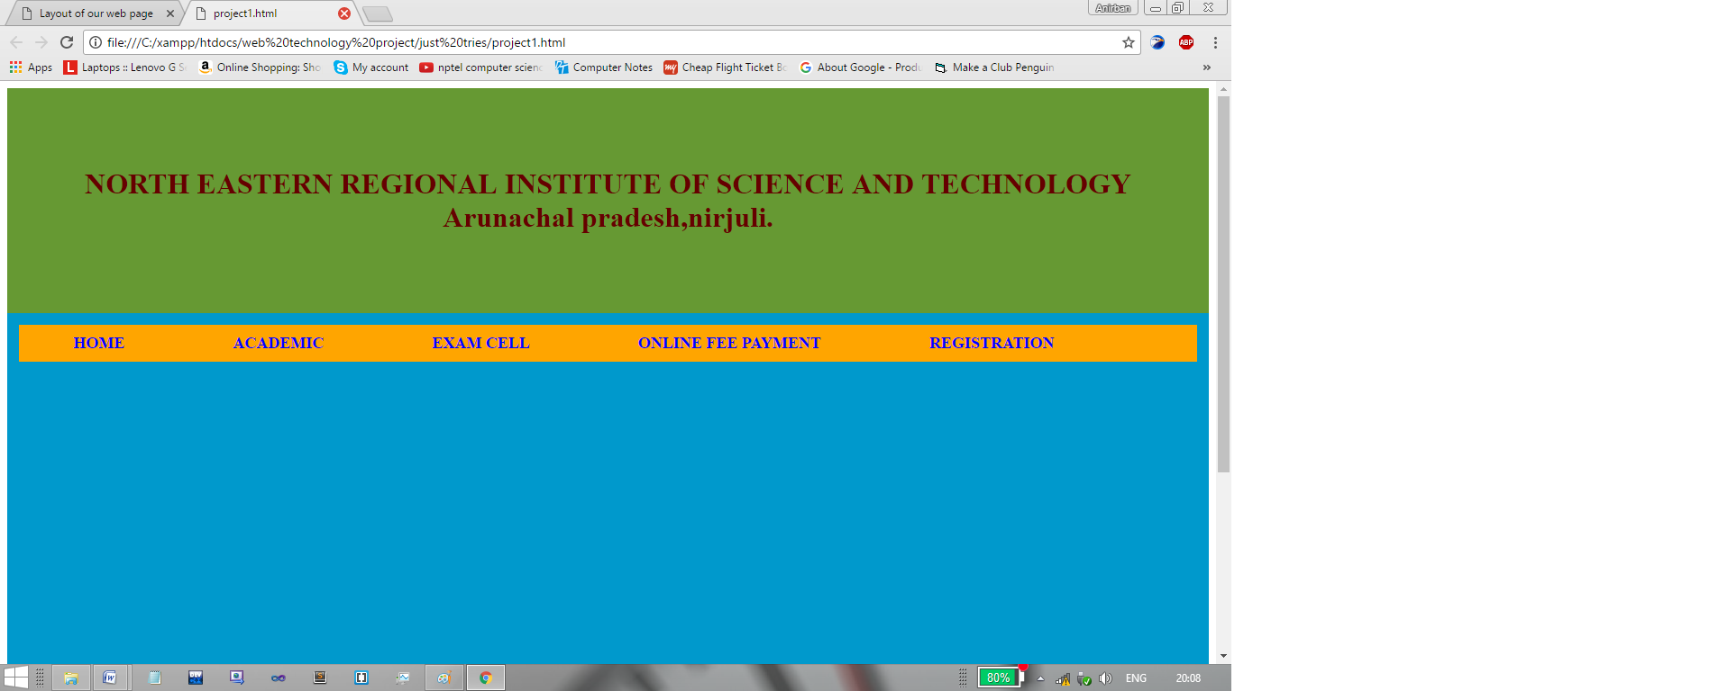

**3.**  Finally, we were able to make this cool and informative main page for our site.

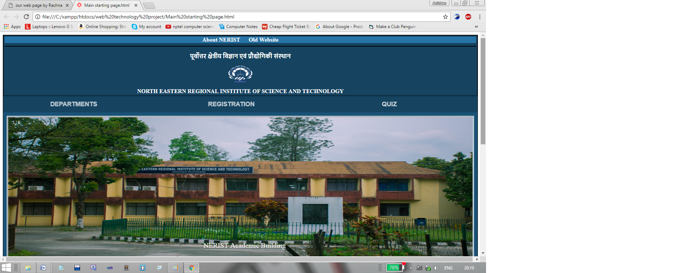

6

This page is having the entire feature that the main page for any online forum should have. And other than this, it is having cooler look. Following features have been added to the page:

a) auto image slider(with 8 beautiful and informative images, which are having the ability to describe our institution.)

b) about NERIST, will take us to a new web page, which holds some valuable information about NERIST along with, some eye catchy beautiful photographs.

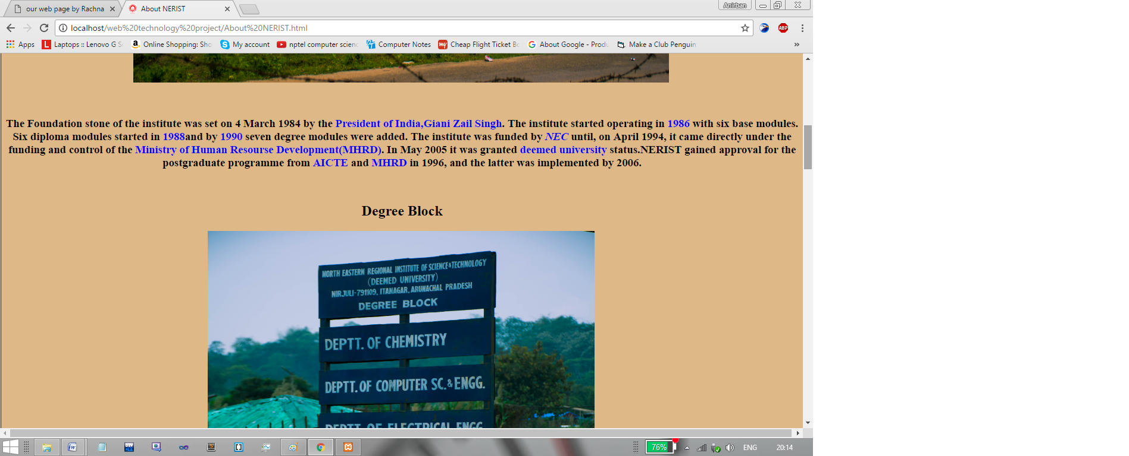

c)It also keeps track of the updates and News about our esteemed institutions, and many more quick links(in the footer section) as shown below.

7

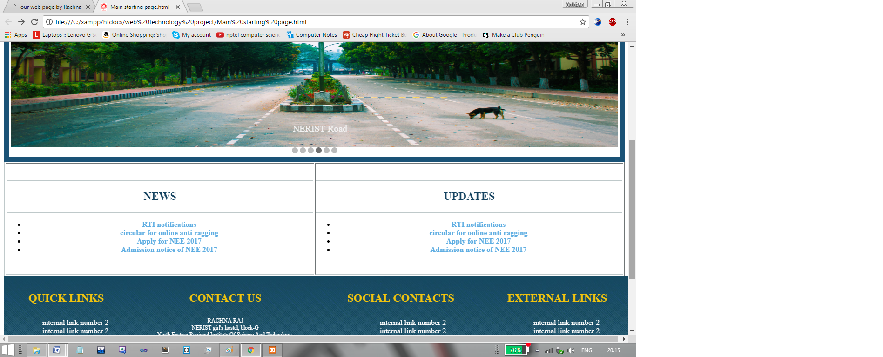

d) Using this beautiful dropdowns, we can redirect to different branches’ Home pages, different registration procedures and interactive quizzes.

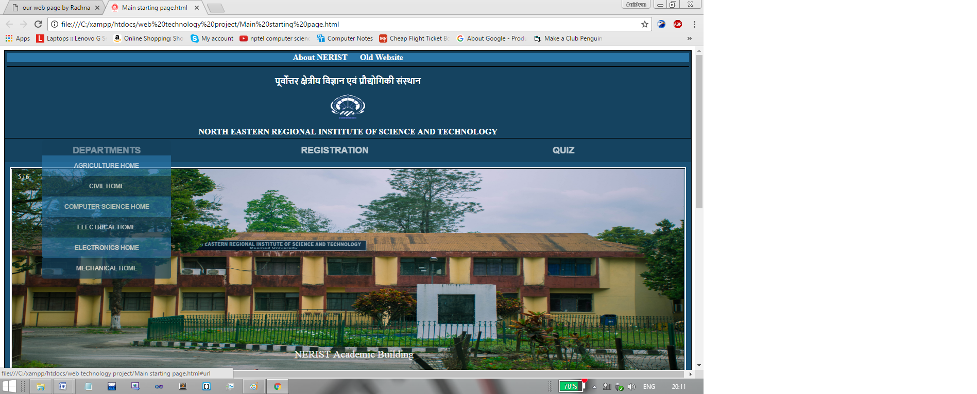

8

e)Using the below dropdown, we can redirect to different kinds of registration (all the different types happens in NERIST).

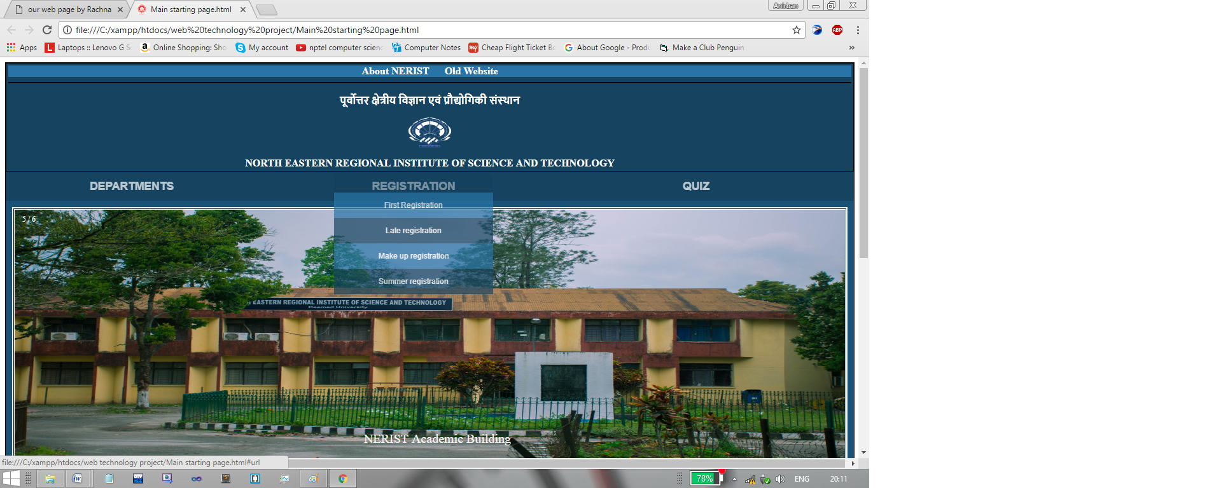

f) Using this dropdown, students can redirect to different branches and have the quizzes prepared by their respective subject teachers.

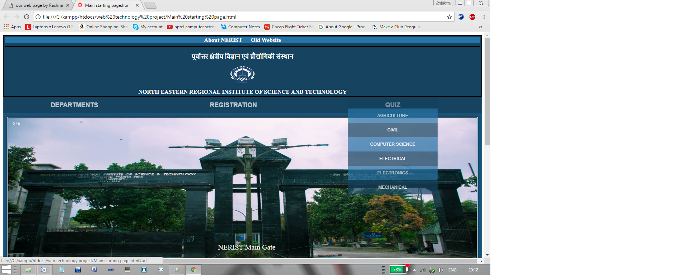

9

g) Snapshot of CSE branch Home page

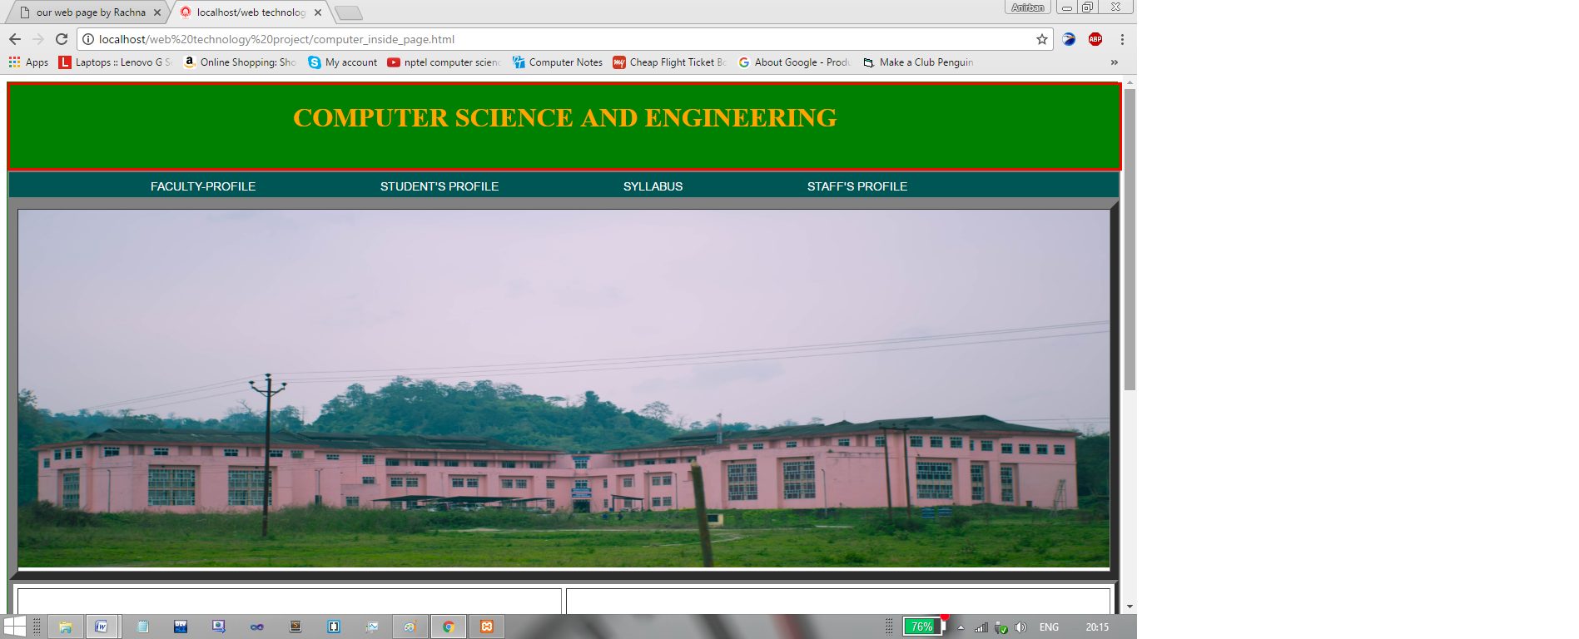

It also have sections, for news and updates, events.

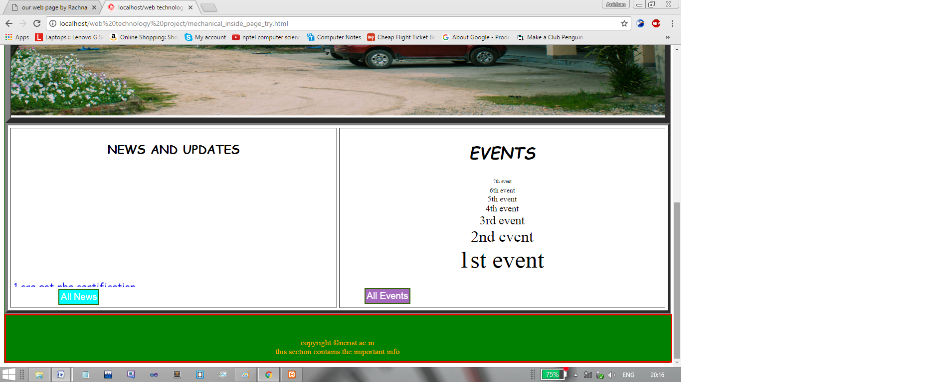

10

Now, this was not the end, we had done lot more, but it will make the number of screenshots huge, so we will skip some of them, but we want to show the quiz page that we had developed after spending a huge time, but we removed it, as we decided to keep our web pages simple.

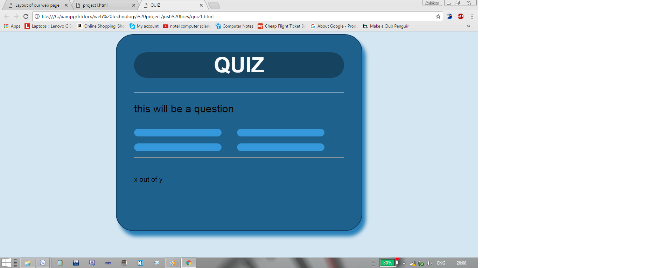

This was the first look of our quiz page, but then we switched to simpler and more user friendly one.

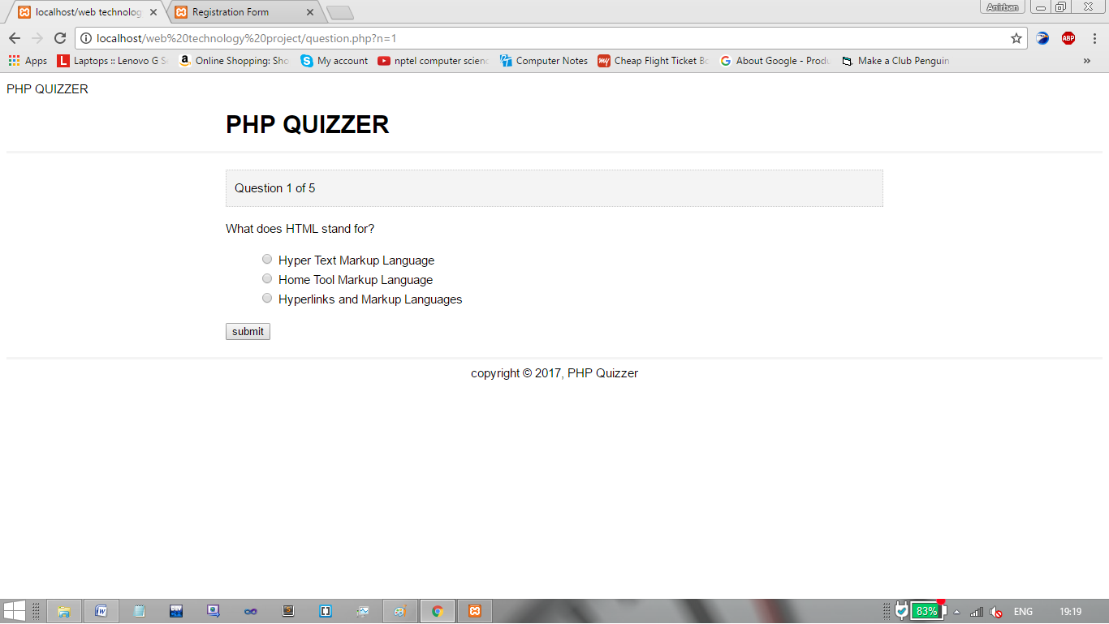

11

**VIEW TO OUR WORK**

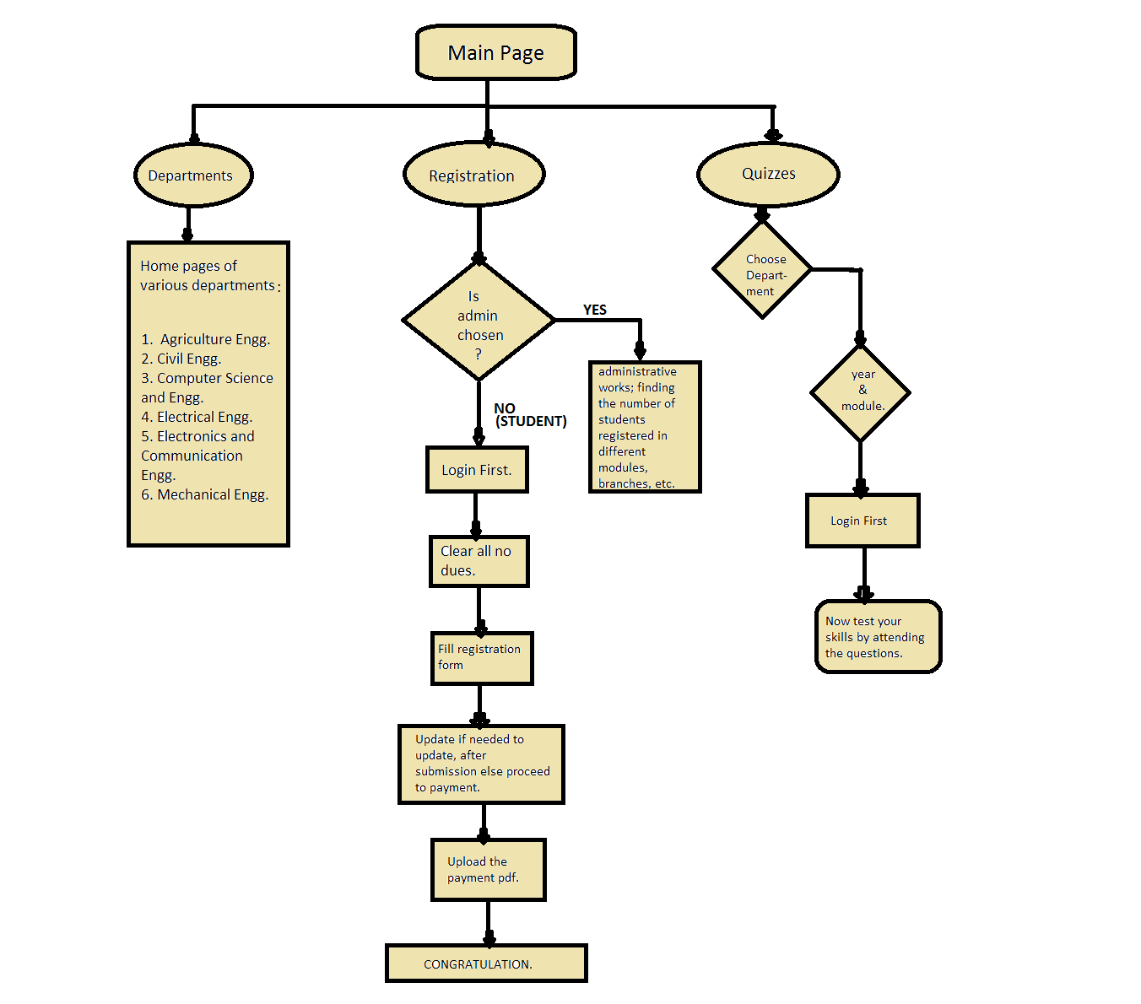

12

The above is the flowchart which is representing the whole of our website. The rest is just coding for the back-end(using PHP and MySQL).

**REGISTRATION PROCEDURE**:

If the student will go for registration, first he will face the below page:

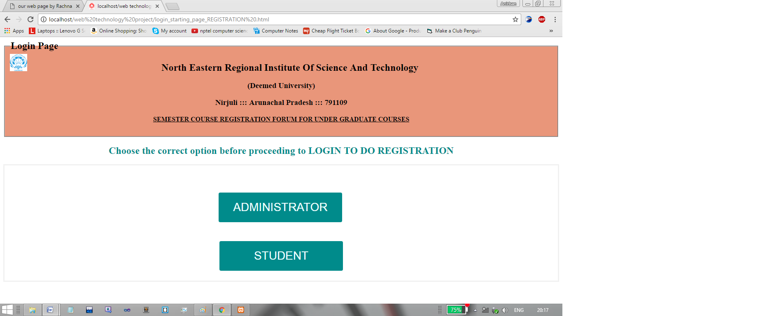

Now, student will go for student (option), where they have to login first by typing their respective roll numbers as Username, and password as follows:

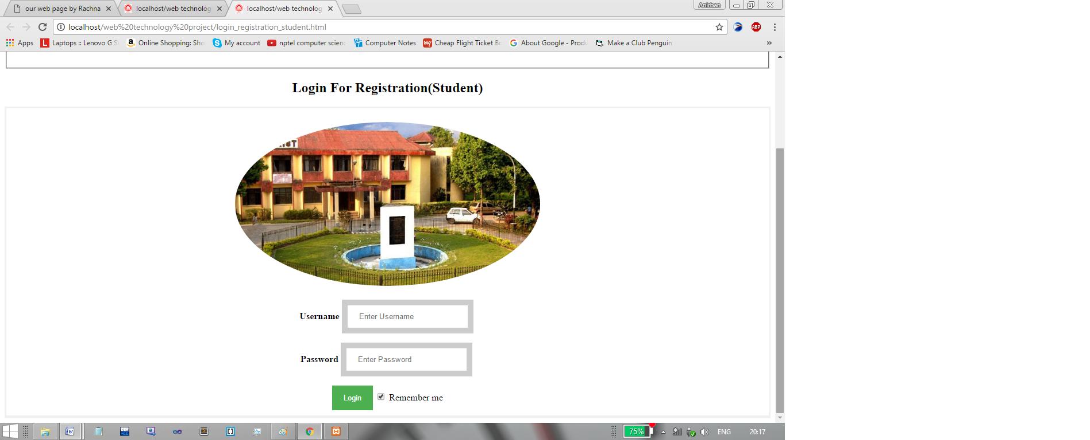

13

After a successful login, the student have to pass through different No Dues, as follows:

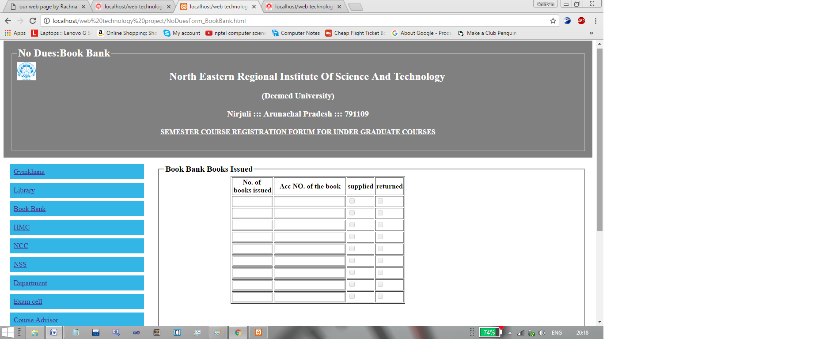Only after clearing all the No Dues, he will ultimately, reach to his/her registration form, which is designed very beautifully by us, which resembles our original registration form:

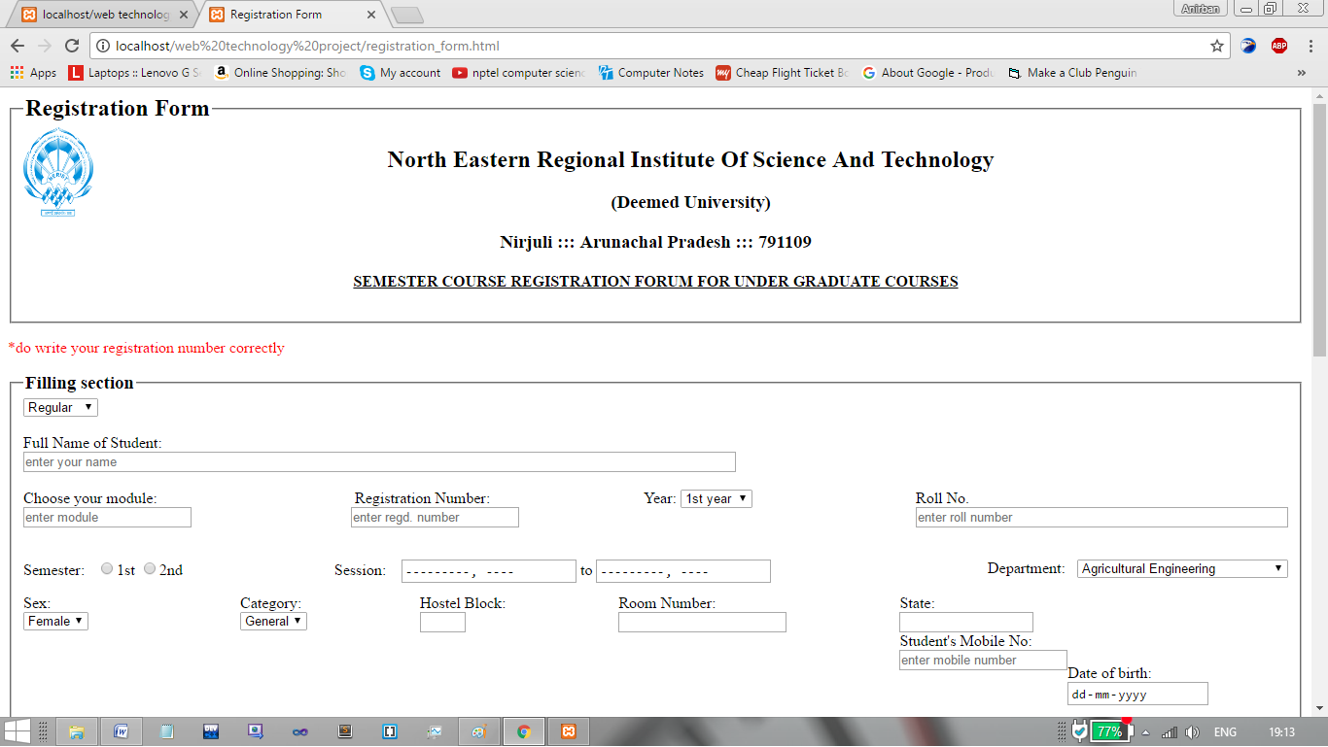

14

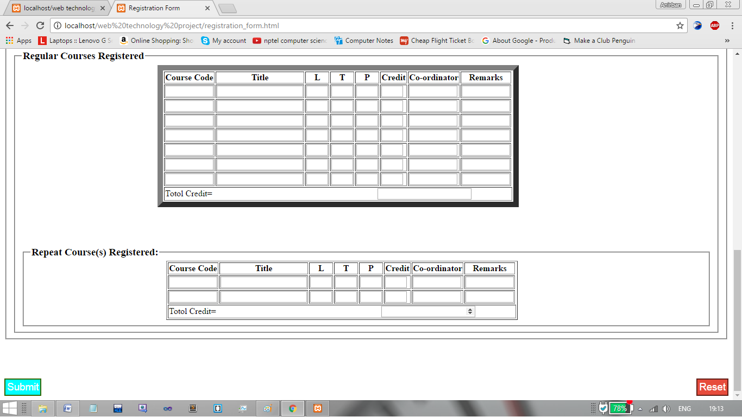

After, completion of filling of the registration form, the person can submit. After submitting also, if he/she desires to rectify some mistake which he/she commited during typing, it is permitted. Then they will proceed to payment(a link to sbi.online) and after completion of the bank deposit, they will have to upload the document to complete their registration, as follows:

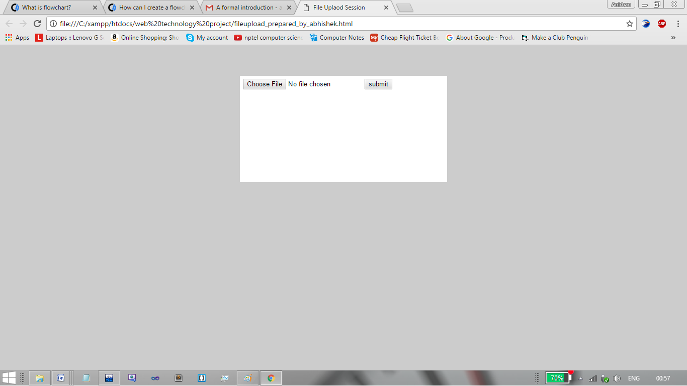

15

After uploading, his/her registration is finished.

**QUIZ PROCEDURE:**

For the quiz, first of all person have to choose the department, to which he/she belong to. Then he/she has to choose his/her year and module.

Then he has to choose the option, whether he/she is an administrator or a student.

If he chooses student, then he has to login first, using his/her roll number and specific password, as follows:

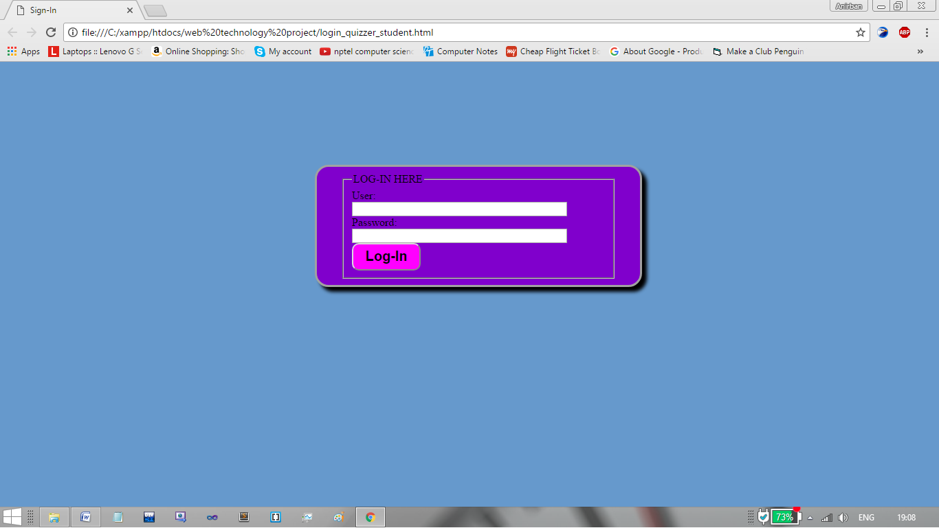

After having a successful login, the student can now enjoy the quiz, and test his/her knowledge base on the question set by his/her teacher himself/herself.

16

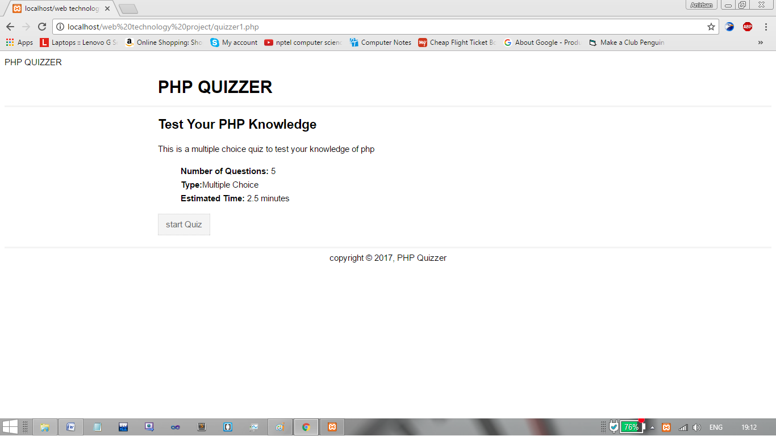

We can see three fields in the starting page of the quiz,

a) The number of questions prepared by your teacher for this particular subject, that you need to attend in order to complete the above session.

b) Type of questions, indicates whether teacher has prepared multiple choice questions or one line questions.

c) Estimated time, is one of the most intelligent field among all the three, as it will automatically increase, on increasing the number of questions (assuming 5 sec per question).

After we press start quiz, we will be facing various questions, prepared by teachers, as follows:

17



And finally, after attending, skipping the questions, we will reach the result page, which displays our score, as follows:

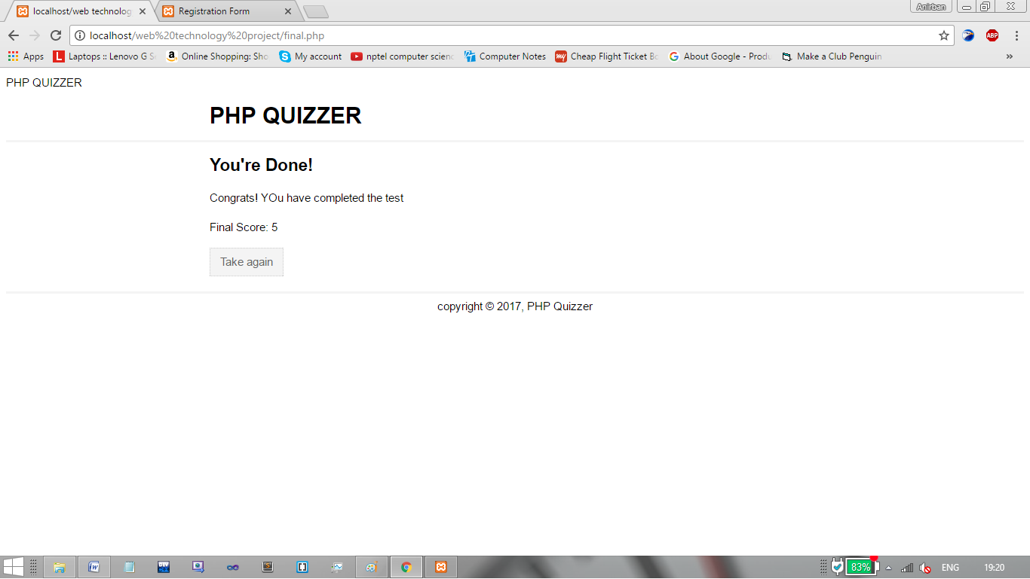

18

As we can notice, that there is a key, given using which we can again have the same quiz, in order to improve our performance.

So, this was all about what student can do, but if we had chosen administrator, then we would had the privilege to set the questions, as follows:

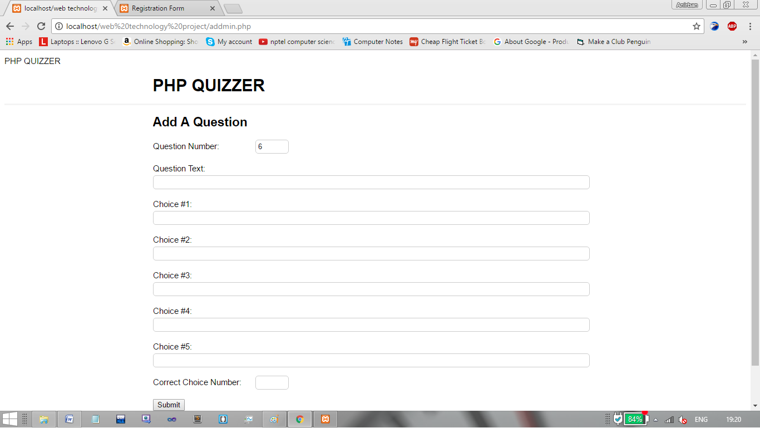

19

**FUTURE ENHANCEMENTS**

This project has been designed after deep thinking and taking under consideration of the problems faced by NERIST students at the starting of the semester or during the semester .This website is very informative. So to make it more interactive, informative and user friendly there are many things yet to be done (which we were not able to do due to lack of time).

** We can include an online discussion forum in this site where students can ask their doubts, clear their concepts via messaging system.

** We can upload the class room lectures for the future references.

** We can share previous year notes to our juniors or mates through this website.

** We can include one more section where students can upload their mini projects or any educational details or creative work among students which can enhance the interest and creative skills among students.

Many more can be done as per the need and requirement of our students. The aim is to make full use of this website in a healthy manner and make it more and more interactive and beneficial.

20

**CONCLUSION**

The time is to give conclusion for our project. We would like to thank everyone who helped us, guided us, and motivated us for this work. It was a great experience and we had a great learning together. After making this project we learned many things, we worked in a group shared our ideas and imaginations. We did many experiments and now we have something to show and conclude at the end.

So at last but not the least we thank all faculty members, students and readers for showing interest in our project.

**THANK YOU!**

21

**REFERENCES**

1)

22